FULL RANGE SPEAKER UNIT AUDIO NIRVANA 6.5〞

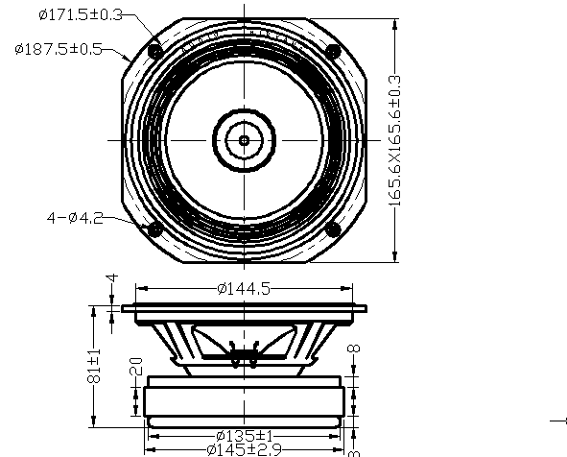
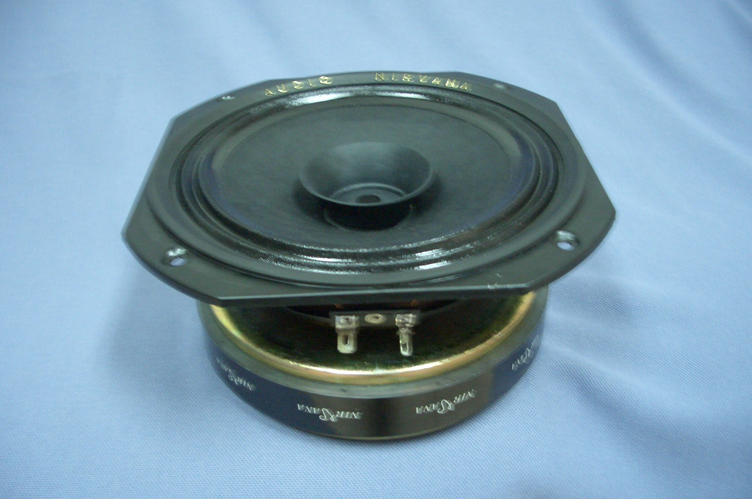

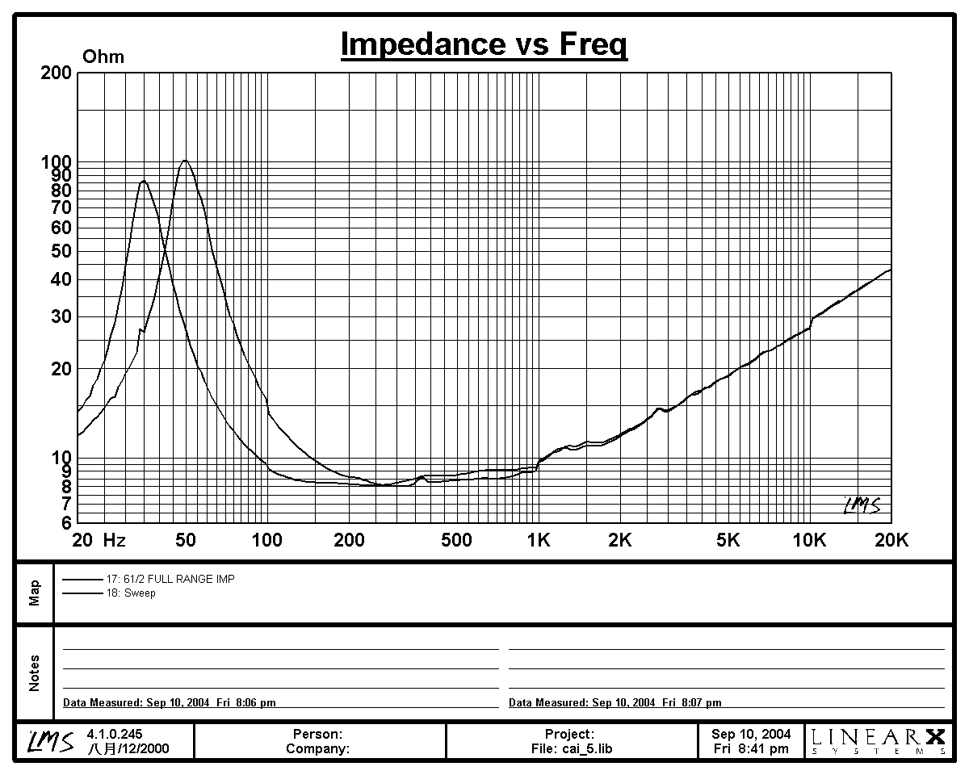
Specifications
&

Thiele/Small Parameters

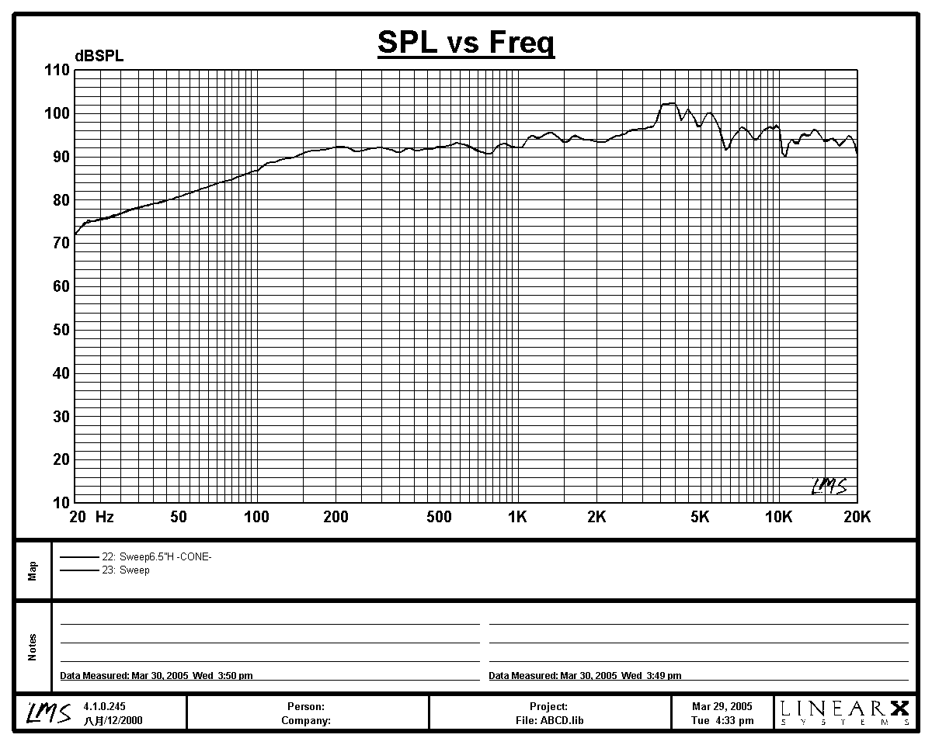

Impedance : 8 Ohm
Minimum Frequency Response
: 51 Hz
Reproduction Frequency Response
: Fo~19K
S.P.L. : 93.3 dB/W(m)
Rated Input : 30 W

Music Power : 50 W

Equivalent Diaghram Radius
: 65 mm
Equivalent Mass : 5.012 g
Magnet Weight : 1400 g
Net Weight : 3420 g
Fs : 51.3 Hz
Re : 7.2 Ohm
Mms : 5.855 g
BL : 6.025TM
Qts : 0.348
Qms : 4.869
Qes : 0.374
Vas : 38.8 Ltr
Xnax : 1.0mm
no : 1.355 %
Material | Frame : 6.5〞Fe
Material | Cone : PAPER+PRESS
Material | Surround : CLOTH
Material | Damper : CONEX
Material | Voice : 30Φ KRAFT
Material | Magnet : 145X50X20 Y30

